A Taste of XSEDE

**Introduction:** **1**

**A New Look At CalcPi** **1**

**Authenticating to XSEDE** **3**

**Using XSEDE** **3**

Login to XSEDE 3

Login to OSG 3

HelloWorld on XSEDE 3

CalcPi on XSEDE 3

# Introduction:

In this class, we are going to take another look at how to use HTCondor to calculate π using Monte Carlo techniques. The HTCondor Resource will be greatly simplified and will also include a few new features. These features are designed to make your life easier, We will then take what we have learned and use it to run on the large resource called XSEDE. Hopefully all the things we have done to get to this point are starting to make sense. I know that working at the command was painful when we started, but I believe that it has helped you to better understand how everything fits together. I am not sure that you would gain the same understanding if we had just clicked a mouse using a GUI.

# A New Look At CalcPi

Make sure that you are logged into the workstation as the unique student for that workstation; studentXXX. Then issue the following commands:

|  |
| --- |
| cd  mkdir -p Condor  cd Condor  curl -o Class-15-Condor.tar.gz \  http://tquark.colorado.edu/computing/Class-15-Condor.tar.gz  tar -xzvf Class-15-Condor.tar.gz  cd Class15/CalcPi |

|  |
| --- |
| **NOTE**: I did package up both the **CalcPi** and **HellowWorld** into a tar file and load it onto a web server in **Colorado**. This was done to make getting it into XSEDE easier. This package is the start of what I have been calling a workflow. I believe that you are capable of doing this on your own. I simply did it to make the class easier. |

The **contents** of the **directory** are a little **different** than the last time we calculated **π**.

|  |
| --- |
| [0] 17:23:56 UTC [drjohn@xd-login:CalcPi]$ ls -al  total 16  drwxr-xr-x 5 drjohn xsede 117 Apr 18 16:52 .  drwxr-xr-x 4 drjohn xsede 36 Apr 18 16:59 ..  -rwxr-xr-x 1 drjohn xsede 642 Apr 9 20:32 CalcPi  -rw-r--r-- 1 drjohn xsede 592 Apr 18 16:51 CalcPi.inputs  -rw-r--r-- 1 drjohn xsede 603 Apr 18 16:43 CondorCalcPi  drwxr-xr-x 2 drjohn xsede 6 Apr 18 16:58 error  drwxr-xr-x 2 drjohn xsede 6 Apr 18 16:58 logs  -rwxr-xr-x 1 drjohn xsede 329 Apr 18 16:51 MakeCalcPiInputs  drwxr-xr-x 2 drjohn xsede 6 Apr 18 16:58 output |

Similarly to when we ran **HelloWorld**, there are three output **directories**:

* output
* error
* logs

The **PERL** script **CalcPi** is the same as we ran previously. The big difference is in:

* **CondorCalcPi** - The Condor Resource Request files has changed
* **MakeCalcPiInputs** - This script will generate a file called CalcPi.inputs. This is simply a list of the arguments that will be passed to CalcPi. This time there will be one condor_submit command. Just watch below.

The **Condor Resource File (CondorCalcPi**) is now:

|  |
| --- |
| ####################  #  # submit description file  # Example 1: queuing multiple jobs with differing  # command line arguments and output files.  #  ####################  **+ProjectName = "TG-CIE170062"**  Executable = CalcPi  **Arguments = $(file)**  Universe = vanilla  #Notification = Never  Output = output/CondorTestJob.$(Cluster).$(Process).out  Error = error/CondorTestJob.$(Cluster).$(Process).err  Log = logs/CondorTestJob.$(Cluster).$(Process).log  ShouldTransferFiles = YES  WhenToTransferOutput = ON_EXIT  TransferInputFiles = CalcPi  **Queue file from CalcPi.inputs** |

The **three** main **differences** are:

* **+ProjectName** = "TG-CIE170062" - You can ignore this for now. This defines the name of our porject in **XSEDE**. It must be in all **HTCondor Resource Files** when we use **XSEDE** to connect us with our **XSEDE** allocation. It will be ignored on our local cluster.
* **Arguments** = $(file) - Now instead of specifying the arguments in the **HTCondor Resource File**, we are telling **HTCondor** that the arguments will be in a file.
* **Queue file from CalcPi.inputs** - This is specifies the file with the list of arguments. Each line in **CalcPi.input** will submit a different “job” to **HTCondor**. For **CalcPi**, each line is just the number of tries for calculating π.

So now we can submit 100 copies (100 is defined in MakeCalcPiInputs) by running:

|  |
| --- |
| ./MakeCalcPiInputs  condor_submit CondorCalcPi |

You can look at a **numerically** sorted list of the results by using:

|  |
| --- |
| cat output/* | sort -n | less |

|  |
| --- |
| **Wow! Wasn’t that easier than the last time?** |

|  |
| --- |
| Of course we could make the same plots as the last time.  I will leave that to you do to do. |

# Authenticating to XSEDE

It is now time to move out of room and into the world. We are finally going to get a taste of XSEDE. Before you can access XSEDE, you must set up multi-factor authentication. To set this up, you will need to load the Duo App onto your SMART device. Even I had to do this. The instructions for setting this up are at:

|  |
| --- |
| https://portal.xsede.org/mfa |

After you have done this, you should be able to login into the XSEDE SSO. These steps are at the bottom of the instructions above.

## 

## Login to XSEDE

|  |
| --- |
| ssh -l YourUserName login.xsede.org |

Since our allocation in on the **Open Science Grid**, you must then enter:

## 

## Login to the OSG

|  |
| --- |
| gsissh osg |

Take notice how much **disk space you are allocated**:

|  |
| --- |
| Your current filesystem usages and quotas are:  /home 0% used (660.0 KB of 20.0 GB)  /local-scratch 0% used (0.0 B of 2.0 TB) |

You have entered **a new world.** For fun, try:

|  |
| --- |
| condor_status |

or

|  |
| --- |
| condor_status | wc -l |

You should get back a number over 7000. That means there are about 7000 batch slots available. Now try:

|  |
| --- |
| condor_status | grep colorado  condor_status | grep colorado | wc |

Remember the rack of computers I showed you a picture of in the very first class. Those are some of the machines you see in the list.

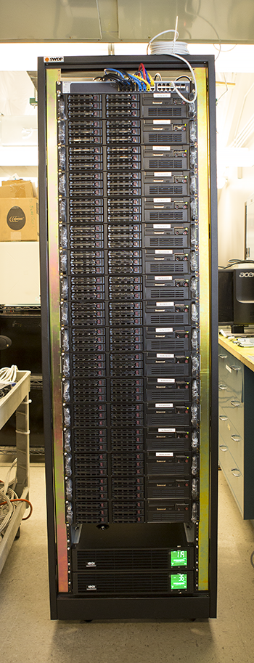

# Using XSEDE

We are now ready to run our jobs on **XSEDE**. The **preparation** we did running on our class cluster will **transfer directly** to running on **XSEDE**. As mentioned above, the only thing that changed is the addition of the **ProjectName** to the **Condor Resource File.**

## HelloWorld on XSEDE

This is identical to what we did in class.

|  |
| --- |
| mkdir Condor  cd Condor  curl -o Class-15-Condor.tar.gz \  http://tquark.colorado.edu/computing/Class-15-Condor.tar.gz  tar -xzvf Class-15-Condor.tar.gz  cd Class15/HelloWorld |

Run one instance of HelloWorld and look to see where it ran:

|  |
| --- |
| condor_submit CondorHelloWorld  condor_q  # After it finishes  cat output/* |

|  |
| --- |
| [0] 18:24:34 UTC [drjohn@xd-login:HelloWorld]$ cat output/*  Hello World, I am running on uct2-c352.mwt2.org |

Now you can run 50 copies of HelloWorld:

|  |
| --- |
| condor_submit CondorHelloWorldMany |

And when it finishes:

|  |
| --- |
| cat output/*  ./CountHosts |

You should see a variety of different host names:

|  |
| --- |
| [0] 18:37:25 UTC [drjohn@xd-login:HelloWorld]$ ./CountHosts  cluster3-111.chpc.ndsu.nodak.edu 6  cluster3-81.chpc.ndsu.nodak.edu 6  compute-1-12.local 5  compute-1-9.local 5  compute-4-11.local 5  mwt2-c008 11  n039 5  osg-718989.0-red-c1627.unl.edu 1  stat112.phys.uconn.edu 3  uct2-c264.mwt2.org 2  uct2-c352.mwt2.org 1  uct2-c478.mwt2.org 1 |

## CalcPi on XSEDE

Now you can do the same thing you did to run the new version of **CalcPi**, except now you are running on a system that has **thousands of CPU cores** available. I have faith that you are now able to do this without my help.

|  |
| --- |
| cd  cd Class15/CalcPc  ./MakeCalcPiInputs  condor_submit CondorCalcPi  cat output/* | sort -n | less |

Please try it to make sure you understand and to be able to tell your friends:

|  |
| --- |
| You are so past cluster computing.  You just did GRID computing.  You are all very amazing!!! |